Supplementary Information
Atomistic Study of Temperature-Dependent Elastic Constants and Tensile Deformation in Magnesium Bicrystals with [$1\overset{ˉ}{2}10$] Symmetric Tilt Grain Boundaries
Saurav Kumar ª, Jaiveer Singh ^{b}, Appala Naidu Gandi ^{b*}
ª Department of Mechanical Engineering, Indian Institute of Technology Jodhpur, Rajasthan 342030, India
^{b} Department of Materials Engineering, Indian Institute of Technology Jodhpur, Rajasthan 342030, India
Lattice parameters and thermal expansion
A series of NPT calculations was performed at each finite temperature to compute the lattice parameters and find the equilibration volume under zero stress conditions. The simulations were run for 40000 MD steps. The lattice parameters a and c, with respect to temperature, were calculated and then compared with the experimental results [1,2] as shown in Fig. S1. Furthermore, the lattice parameter was found to be 3.231Å with the c/a ratio of 1.622 at 300 K. Additionally, it was observed that the lattice parameters increase with temperature due to thermal expansion. Experimentally, the ‘a’ lattice parameter and the c/a ratio were determined to be 3.209 Å, 1.6234 through X-ray diffraction studies [3,4]. Moreover, the calculated lattice parameters only deviate 0.2% to 1.18% for the a-parameter, and 0.07% to 1.11% for the c-parameter when compared to the experiments as shown in Fig.S1.
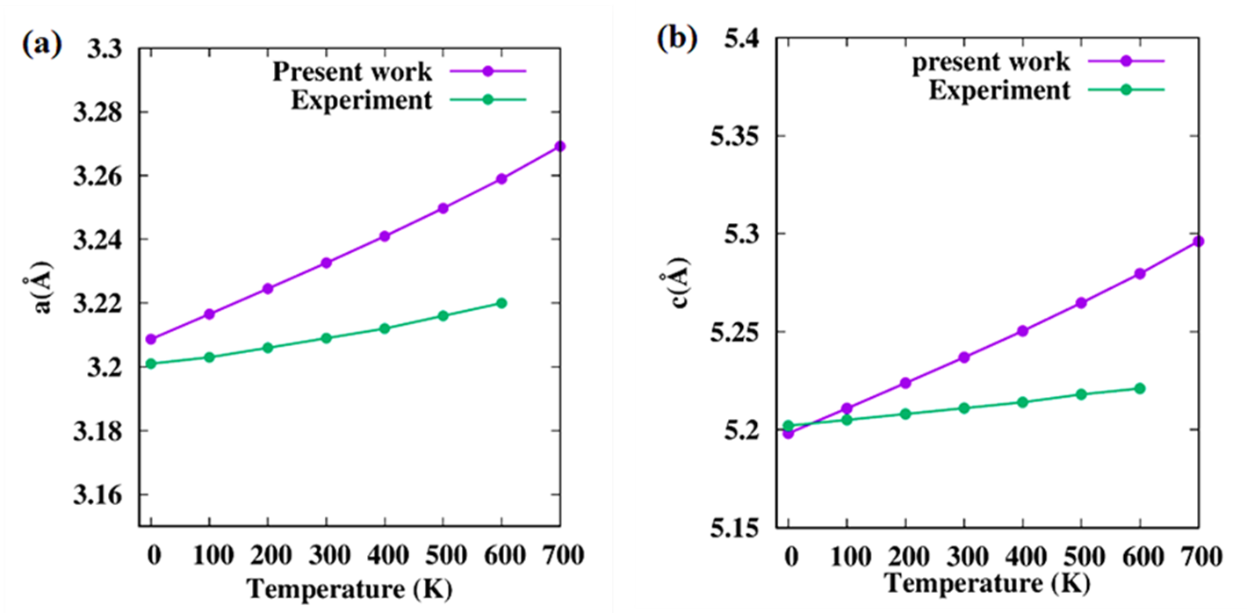
Figure. S1 Calculated lattice constants of Mg (a) along a direction and (b) along c direction compared with experimental results.
To calculate the elastic stiffness tensor with respect to temperature, we need to compute the linear thermal expansion coefficients. While running a series of NPT simulations, we can calculate this parameter using the formulation:
$α_{a}= \frac{1}{a_{RT}} \frac{da}{dT}$ , $α_{c}= \frac{1}{c_{RT}} \frac{dc}{dT}$ (7)
The linear thermal expansion coefficients of Mg are calculated and compared with the experimental results as shown in Fig 2. Furthermore, the linear thermal expansion coefficient was found to be 26.56 x 10⁻⁶ K⁻¹ in the a-direction and 25.96 x 10⁻⁶ K⁻¹ in the c-direction at 300 K. Literature data from the experiments and the first-principles calculations [5] were compared with the calculated data for co-efficient of thermal expansion along the a and c directions and shown in Figs. S2(a and b), respectively.
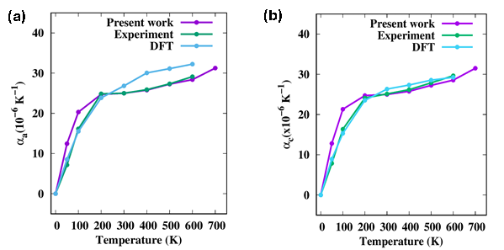
Figure. S2 Calculated Linear thermal expansion coefficient of Mg as a function of temperature (a) along a direction and (b) along the c direction is compared with the experimental data and DFT data from the literature.

Table S1 Contribution of born term, kinetic term, and fluctuation term to the estimated stiffness tensor at different temperatures.
T (K) | C_{ij}, GPa | Kinetic Energy term | Born term | Fluctuation term | Total
0 | C11 | 0.00 | 64.940 | 0.00 | 64.940
 | C12 | 0.00 | 24.247 | 0.00 | 24.247
 | C13 | 0.00 | 21.230 | 0.00 | 21.230
 | C33 | 0.00 | 69.779 | 0.00 | 69.779
 | C44 | 0.00 | 17.162 | 0.00 | 17.162
 | C66 | 0.00 | 20.333 | 0.00 | 20.333
100 | C11 | 0.236 | 63.485 | 2.367 | 61.354
 | C12 | 0.0 | 23.650 | 1.262 | 22.388
 | C13 | 0.0 | 20.524 | 1.597 | 18.927
 | C33 | 0.236 | 68.450 | 3.002 | 65.684
 | C44 | 0.118 | 16.739 | 0.317 | 16.540
 | C66 | 0.118 | 19.954 | 0.953 | 19.119
200 | C11 | 0.468 | 62.461 | 4.132 | 58.797
 | C12 | 0.0 | 22.986 | 1.904 | 21.082
 | C13 | 0.0 | 19.779 | 2.521 | 17.258
 | C33 | 0.468 | 67.478 | 4.697 | 63.249
 | C44 | 0.234 | 16.354 | 0.559 | 16.209
 | C66 | 0.234 | 19.796 | 1.833 | 18.197
300 | C11 | 0.696 | 61.332 | 5.493 | 56.535
 | C12 | 0.00 | 22.330 | 2.687 | 19.643
 | C13 | 0.00 | 19.085 | 3.088 | 15.997
 | C33 | 0.696 | 66.376 | 5.714 | 61.358
 | C44 | 0.348 | 16.310 | 0.796 | 15.862
 | C66 | 0.348 | 19.553 | 2.156 | 17.745
400 | C11 | 0.924 | 60.071 | 7.719 | 53.276
 | C12 | 0.0 | 21.723 | 3.132 | 18.591
 | C13 | 0.0 | 18.440 | 4.174 | 14.266
 | C33 | 0.924 | 65.161 | 7.634 | 58.451
 | C44 | 0.462 | 15.999 | 1.295 | 15.166
 | C66 | 0.462 | 19.214 | 2.437 | 17.239
500 | C11 | 1.144 | 58.597 | 8.798 | 50.943
 | C12 | 0.0 | 21.147 | 3.468 | 17.679
 | C13 | 0.0 | 17.879 | 4.600 | 13.279
 | C33 | 1.144 | 63.718 | 8.898 | 55.964
 | C44 | 0.572 | 15.691 | 1.473 | 14.790
 | C66 | 0.572 | 18.815 | 2.277 | 17.110
600 | C11 | 1.364 | 57.143 | 10.613 | 47.894
 | C12 | 0.0 | 20.598 | 4.853 | 15.745
 | C13 | 0.0 | 17.370 | 5.432 | 11.938
 | C33 | 1.364 | 62.181 | 11.061 | 52.484
 | C44 | 0.682 | 15.248 | 1.745 | 14.185
 | C66 | 0.682 | 18.343 | 3.902 | 15.123
700 | C11 | 1.576 | 55.313 | 13.547 | 43.342
 | C12 | 0.0 | 20.031 | 6.015 | 14.016
 | C13 | 0.0 | 16.839 | 8.470 | 8.369
 | C33 | 1.576 | 60.429 | 16.865 | 45.484
 | C44 | 0.788 | 14.912 | 1.959 | 13.741
 | C66 | 0.788 | 17.177 | 3.926 | 14.639

References
- L.J. Slutsky, C.W. Garland, Elastic Constants of Magnesium from 4.2°K to 300°K, Physical Review 107 (1957) 972–976. https://doi.org/10.1103/PhysRev.107.972.
- E. Garlea, M. Radovic, P.K. Liaw, High-temperature dependency of elastic mechanical behavior of two wrought magnesium alloys AZ31B and ZK60A studied by resonant ultrasound spectroscopy, Materials Science and Engineering: A 758 (2019) 86–95. https://doi.org/10.1016/j.msea.2019.04.115.
- P. Paufler, C. S. Barrett, T. B. Massalski. Structure of Metals. 3rd revised edition. Pergamon Press Oxford, New York, Toronto, Sydney, Paris Frankfurt/M 1980 654 Seiten, 113 Abbildungen, 19 Tabellen und über 1400 Literaturhinweise. Preis US $ 20, Kristall Und Technik 16 (1981) 982–982. https://doi.org/10.1002/crat.19810160904.
- F.W. von Batchelder, R.F. Raeuchle, Lattice Constants and Brillouin Zone Overlap in Dilute Magnesium Alloys, Physical Review 105 (1957) 59–61. https://doi.org/10.1103/PhysRev.105.59.
- D.E. Gray, I.E. Dayton, American institute of physics handbook, Am J Phys 32 (1964) 389.

